# 02. Photography

You are given an unresponsive website (**HTML** + **CSS** + images). Your task is to **make the site responsive**.

The site layout should change according to the browser viewport / screen size.

You need to implement 1 layout: **width <= 600px**. The figures below represent this layout:

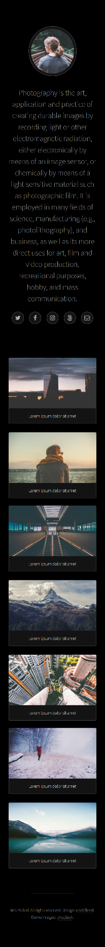

## Output

The output should be valid **HTML5** + **CSS3** + **images** that implement the above responsive site.

## Constraints

* You are **NOT** allowed to change the given **HTML** and **CSS**
* Pixel - perfect implementation is **NOT** required